Rotary Club of Ku-Ring-Gai Inc.
PO Box 117 GORDON NSW 2072
Director – Vocational Service: (name)
Ph: 02 …….., Email: ……
date
Company
And address
By email

Dear …….,

Pride of Workmanship Award Presentation
Do you have an employee who consistently puts in extra effort that is rarely recognised or rewarded?

This is an invitation from the Rotary Club of Ku-ring-gai to participate in the “Pride of Workmanship” Award Scheme sponsored by our club.

Nominate Someone Who Makes a Difference
The scheme gives your company the opportunity nominate a special employee for public recognition of their outstanding qualities in terms of approach, attitude, dedication and commitment to his/her job and therefore stands out as a successful achiever. It is intended to cover all aspects of work performance including ethics, quality and quantity of output, safety, initiative, sense of responsibility, etc.

Public Reward for Worthy Employees
We honour the selected employees at a special dinner and present them with a beautiful plaque. We will also offer extra recognition for them and your company via the local media.
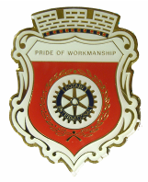
It is Important to Australia and Our Community
We believe “Pride of Workmanship” – the sense of responsibility to “Do a Job Once, Do it Well and Build a Better Australia” is one of the greatest intangible assets in our community.

To encourage “Pride of Workmanship”, our club is offering the opportunity through Rotary of acknowledging the efforts and contributions of employees who consistently achieve an overall high standard of work performance and also display personal qualities worthy of such a public award.
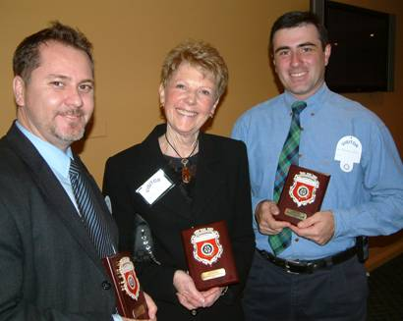
Pictured are some previous happy awardees:
Juan Perez, Ku-ring-gai Council; Joan Anderson, Lifeline - Harbour to Hawksbury; and Acting Sergeant Michael Lewis, Hornsby Police

Successful nominees will receive their awards at a Rotary Club Presentation Dinner to be held at the West Pymble Bowling Club on Monday evening, ….date …. If your candidate is selected, there would be a nominal fee to cover the cost of a plaque and dinner for one awardee and his/her partner.

If this scheme appeals to you and you would like to nominate one of your members, please complete the separate nomination form enclosed and return to ……….by date to allow time for engraving. For more information, do not hesitate to contact me on ……….. or email: ……………….

Help us to help you by encouraging “Pride of Workmanship” in our community. The smiles say it all.

Yours sincerely

name
Director – Vocational Service
Rotary Club of Ku-ring-gai Inc.

