
MEDIA RELEASE

Date:
Issued by: Rotary Club of Ku-ring-gai.

For further information contact:

name, Rotary Club of Ku-ring-gai,

ph: email:

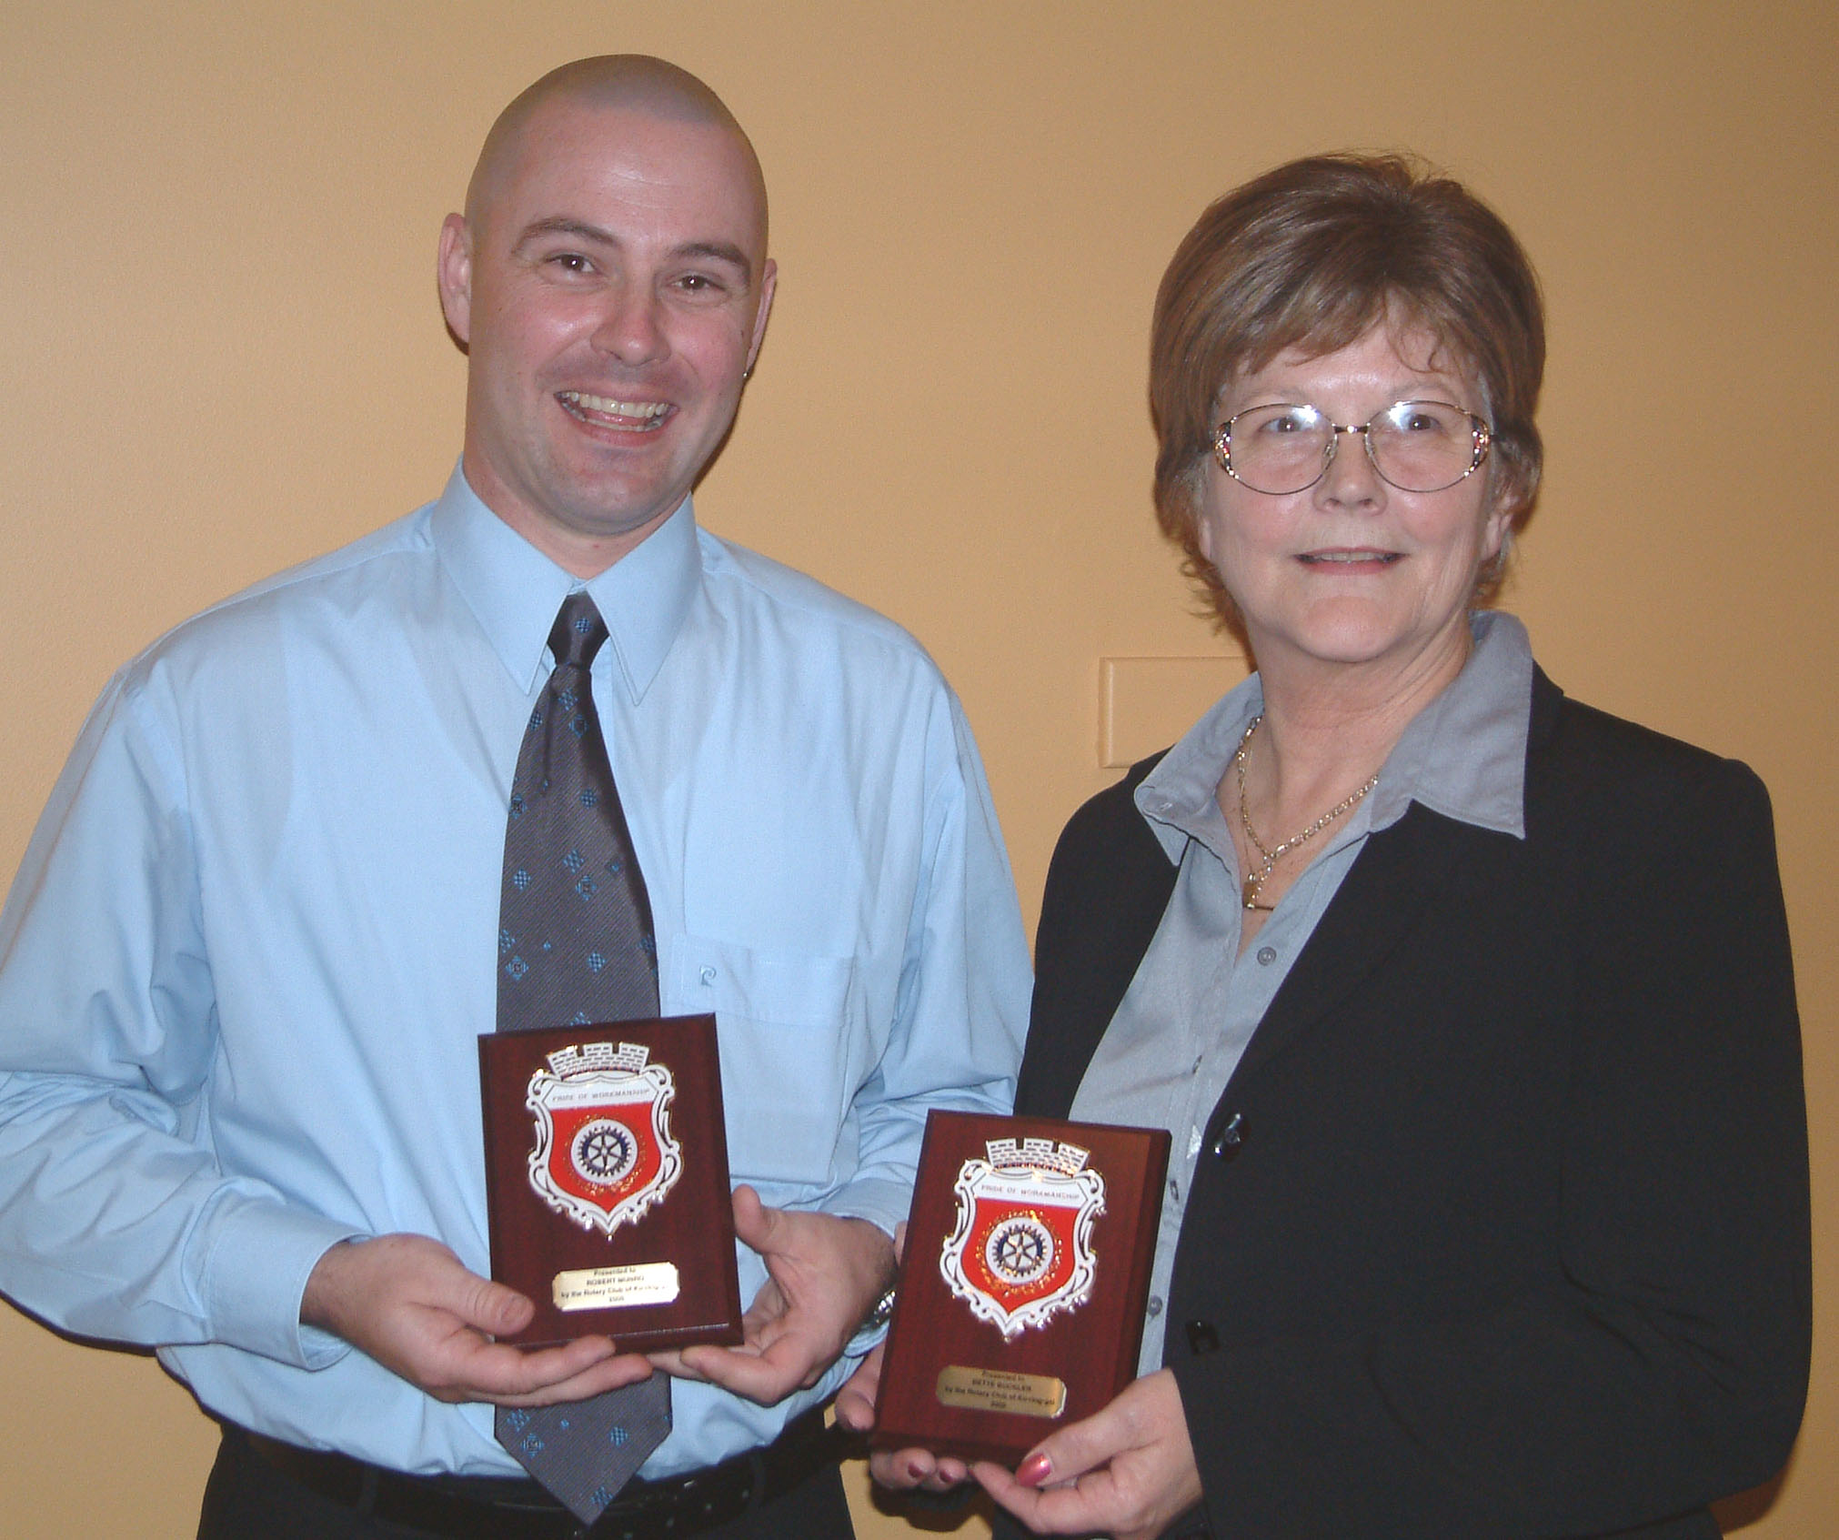

Extra Effort Recognised
by Rotary Award

Robert Munro of Northside Volvo Gordon and Bette Buckler of Healthcall Epping Nursing Agency proudly show their awards

The Rotary Club of Ku-ring-gai presented two outstanding employees of local companies with ‘Pride of Workmanship’ awards at a special function on Monday 31 October. Robert Munro of Northside Volvo Gordon and Bette Buckler of Healthcall Epping Nursing Agency were recognised for their dedication, loyalty and for contributing to the building of a better Australia.

Ross Egan, president of the Rotary Club of Ku-ring-gai while presenting the awards said: “the awardees were chosen from over 100 companies approached by the club.”

The Rotary Club of Ku-ring-gai provides local organisations the opportunity to recognise their employees, in a way employers may have difficulty emulating. Ross said that the awardees had consistently exceeded the expectations of their roles normally expected by both their customers and their employers, by demonstrating excellent dedication, loyalty and always “going that extra mile” to help their customers.

Employers are often conscious of employees who consistently put in that extra effort that is rarely recognised or rewarded. Somehow we overlook the personal touch,” he said; “the good old fashioned values and we forget to look the person straight in the eye and say ‘well done’.”

“The award program was started by the Rotary Clubs of Ryde and Pennant Hills in 1975, after a number of Rotarians expressed concern at the apparent lack of pride of workmanship generally exhibited in all walks of life. The award is now used by over 600 Rotary Clubs in Australia, New Zealand, the South Pacific, Malaysia, Canada and the USA.

About the Rotary Club of Ku-ring-gai
The Rotary Club of Ku-ring-gai holds a dinner meeting with invited guest speakers from 6.30pm on Mondays at West Pymble Bowling Club. Members are men and women, aged over 30, drawn from a wide range of businesses and professions in Ku-ring-gai. Members also contribute their skills to perform service for the local community. The club’s aim is for members to have fun through participation in community, youth and international projects and club social events.
For information about Rotary, phone: (name) on (phone) or visit the website: www.kuringgairotary.org.au - ends

